ENGLISH-5
TEST
1. Прослушайте разговор Алана и Пэт. Соотнесите родственников Пэт и их занятия. Три занятия в списке лишние. Вы услышите диалог два раза.
Pat's family | 1) aunt 2) cousin 3) grandmother  4) father 5) mother
Activities | a) reading b) eating c) painting  d) phoning e) playing f) sweeping  g) cleaning h) drinking
2. Соотнесите две части словосочетаний.
1) to follow | a) the museums
2) to rake | b) the postcards
3) to visit | c) the leaves
4) to send | d) the radio
5) to listen to | e) the tickets
6) to reserve | f) the rules
3. Выберите правильный вариант для заполнения пропусков.
1) I've bought a car and soon I ___. a) will drive b) drive c) am driving
2) She has ___ done gymnastics. a) already b) yet c) often
3) I ___ a dog now. a) am seeing b) see c) to see
4) He ___ a trip twice a year. a) make b) making c) makes
5) I ___ there since 1985. a) wasn't b) amn't c) haven't been
6) They ___ singing when I came. a) are b) were c) was
7) Last week I ___ care about my pet. a) must b) had to c) may
8) The train will arrive ___ 10 hours. a) in b) on c) at
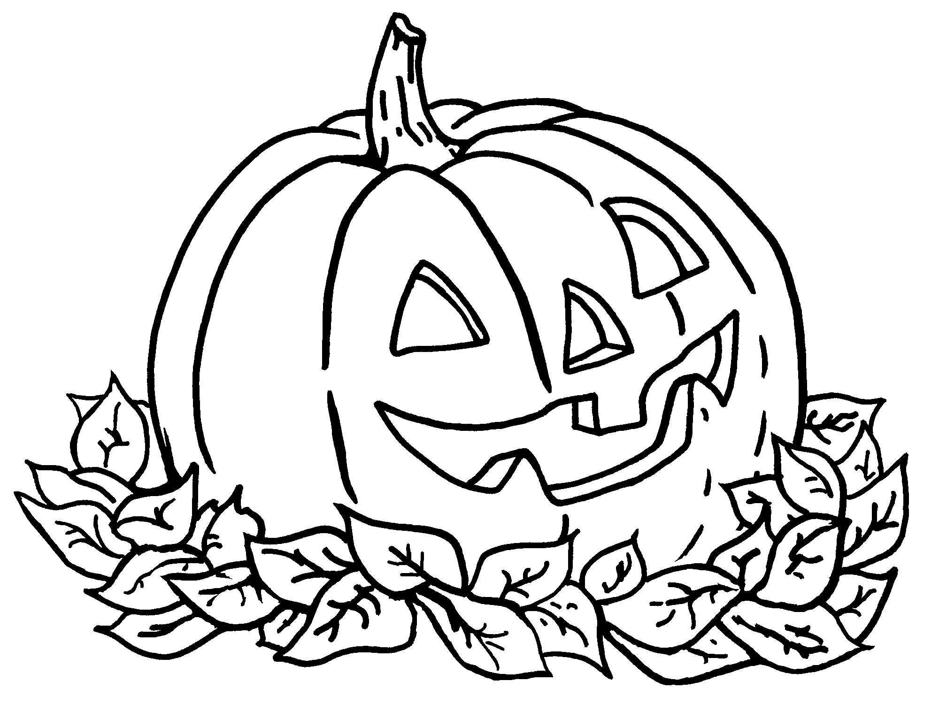
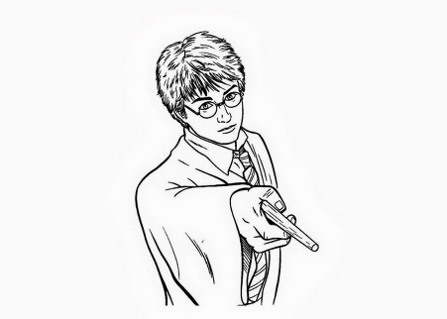
4. Соотнесите имена собственные и их значения.
1) The Thames | a) People celebrate it in autumn.
2) Halloween | b) He is a character of the book.
3) Scotland | c) It's the river in London.
4) Windsor Castle | d) It's a part of the UK.
5) Harry Potter | e) It's a theme park.
6) Disneyland | f) The Queen lives there.
5. Прочитайте текст и определите истинность утверждений 1 - 5 после него. Ответ выберите из вариантов a и b.
Robert, Harry and the smart dog
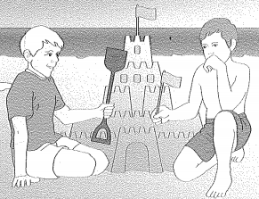
Last summer, Robert and Harry stayed at their grandparents' house by the sea. One hot and sunny morning, Grandmother made a picnic and took the boys to the beach. After lunch, Grandmother laid down and opened her book. The boys were playing football on the beach and then made a little castle with some sand.
Then Harry saw a strange cave which was near some big, grey stones at the other end of the beach. The boys quickly ran to it and looked in, but they couldn't see anything because it was very dark. Harry said, "It looks big inside. Come on! I'll go first."
Harry and Robert were playing inside the cave when suddenly Robert said, "Oh no! I can hear the sea! It's coming into the cave." They were very afraid, but then Harry felt something wet on his hand. It was their dog's nose! The dog was very smart. It showed the boys the way out of the cave and back to the beach.
When they told their grandmother about the dog, she gave it three biscuits and said, "Well done!" "We're hungry too" the boys said, "Well", Grandmother answered, "you must wait when we have a dinner. It was silly to go into a dangerous place like that." "We're very, very sorry, Grandma!" they said. "We won't do it again."
a) true b) false
1) The weather was hot and rainy.
2) Harry went first into the cave.
3) It was dark in the cave.
4) The dog couldn't help the boys.
5) Grandmother gave the boys tasty things.
6. Восстановите верный порядок слов в вопросах.
1) What / they / reading / now? / are
2) you / to join / want / Do / the race?
3) ever / Have / been / you / Paris? / to
4) are / going / to / Where / you / travel?
5) he / did / Why / his / clean / room?
7. Напишите 5 предложений о себе. В каждом случае сообщите требуемую информацию.
1) your name and age;
2) when you celebrate your birthday;
3) your favourite holiday;
4) the most difficult school subject for you;
5) the place where you like to spend your summer time.

